[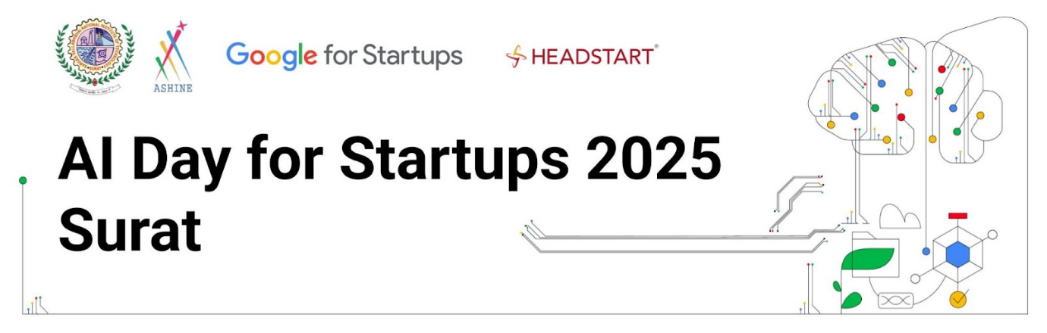](https://drive.google.com/file/d/1r8iJMszgcu0gI0lo5nraxeCFI3pwettQ/view?usp=drive_link)

**AI Day for Startups 2025 - Surat**

**Date & Time:** 4th September| 9:30 am - 4:30 pm

**Venue**: ASHINE, S.V. National Institute of Technology, Surat

Join the "**AI Day for Startups - SURAT**" event hosted by **ASHINE, S.V. National Institute of Technology, Surat and Headstart in collaboration with Google for Startups** and master the latest Generative AI tools and integrate them seamlessly into your applications.

AI Day for Startups is a series of multi-format events, designed by Google for Indian startups and hosted with the startup ecosystem partners across the country, to **equip early-stage startups with the knowledge and tools to seamlessly integrate Generative AI solutions into their products**.

Last year the focus was on helping startups getting started on GenAI, this year the focus is around bringing [insights](https://cloud.google.com/resources/content/future-of-ai-report) and hands-on experience around **AI Agents**, **Multimodal AI**, and discussing **AI Commercialization** (including ROI).

Upskill, explore, and network with like-minded startup founders and developers at our interactive sessions, and hands-on codelabs, learning from Google's best as you build real-world Generative AI solutions.

Register today to reserve your spot!

**RSVP Here**:[**goo.gle/AI-Day-Startups**](https://goo.gle/AI-Day-Startups)

(select “***AI Day for Startups 2025 - Surat [Google x NIT Surat] - September 4th, 2025*** ” from the event list)

**Agenda:**

|  |  |  |
| --- | --- | --- |
| **Time** | **Duration** | **Session Name** |
| 9:30 am - 10:30 am | 60 mins | Check-in & Breakfast |
| 10:30 am - 10:45 am | 15 mins | Welcome Note |
| 10:45 am - 11:45 am | 60 mins | Panel Discussion on "AI's Next Wave: Agents, Multimodal, and Monetization" |
| 11:45 am - 12:45 pm | 60 mins | Google AI Talk (Introduction to Gemini 2.5, Gemma 3.0, Vertex AI, AI Studio, Multimodal Live, Imagen, Veo) |
| 12:50pm - 1:30 pm | 45 mins | Lunch Break |
| 1:30 pm - 2:30 pm | 60 mins | Codelab 1 - [Build a Travel Agent using MCP Toolbox for Database](https://codelabs.developers.google.com/travel-agent-mcp-toolbox-adk#0) |
| 2:30 pm - 3:00 pm | 30 mins | Codelab 2 - [Introduction to Gemini 2.5 Pro on Google Cloud](https://codelabs.developers.google.com/codelabs/intro-gemini-25-pro-colab#0) |
| 3:00 pm -3:30 pm | 30 mins | Prototype, build, and run full-stack AI apps with Firebase Studio |
| 3:30 pm - 3:45 pm | 15 mins | Google for Startups Programs |
| 3:45 pm - 4:00 pm | 15 mins | Closing |
| 4:00 pm - 4:30 pm | 30 mins | High tea & Networking |